


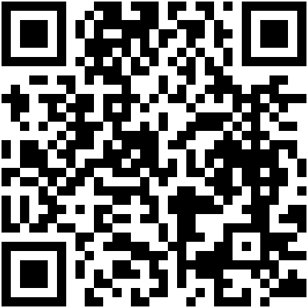

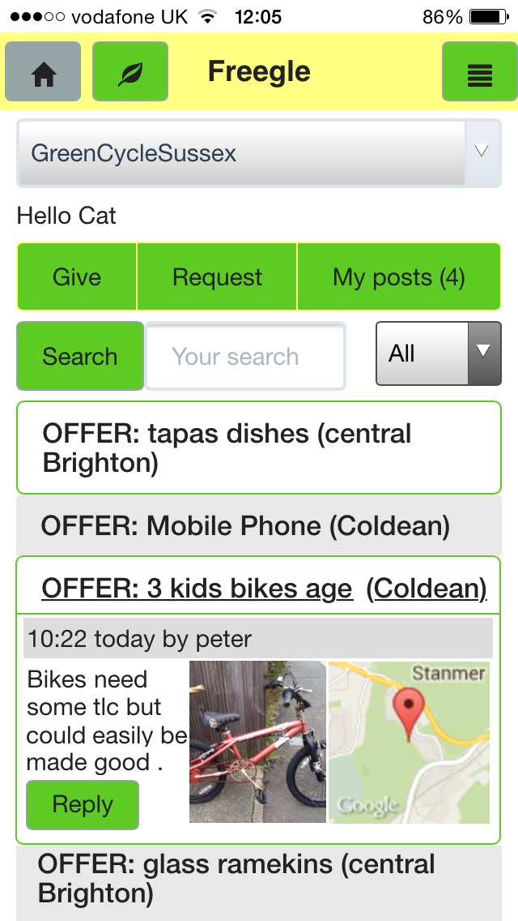
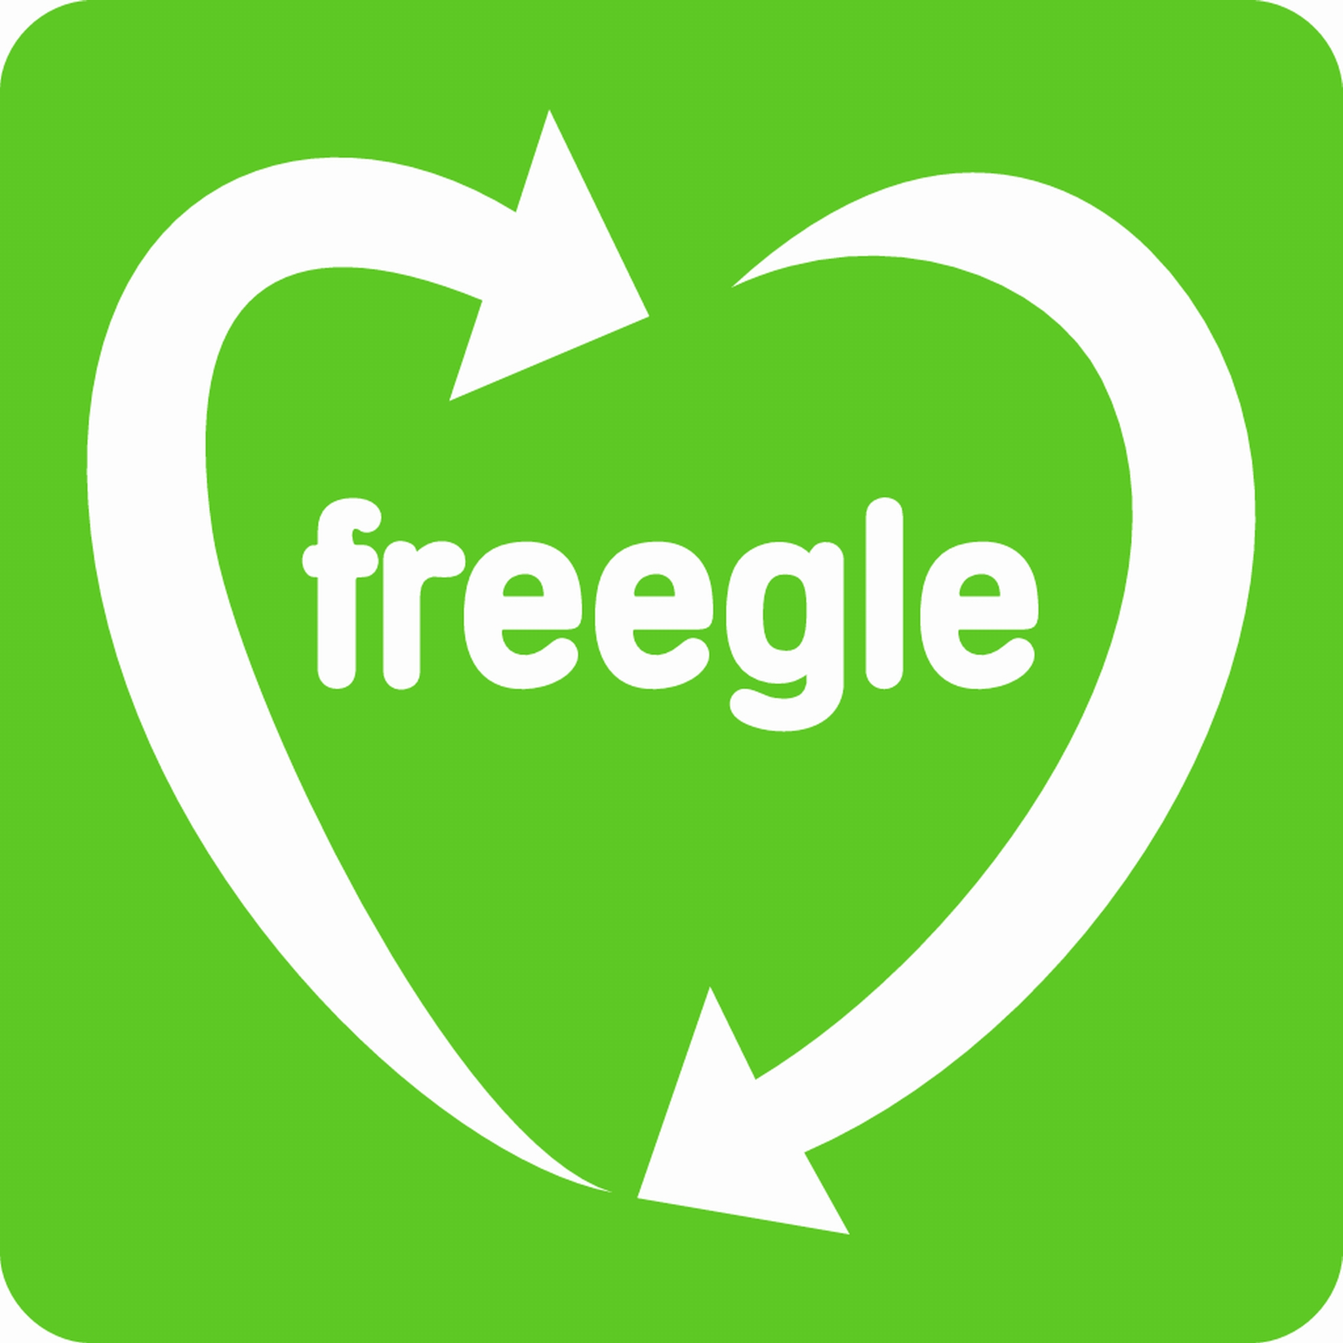
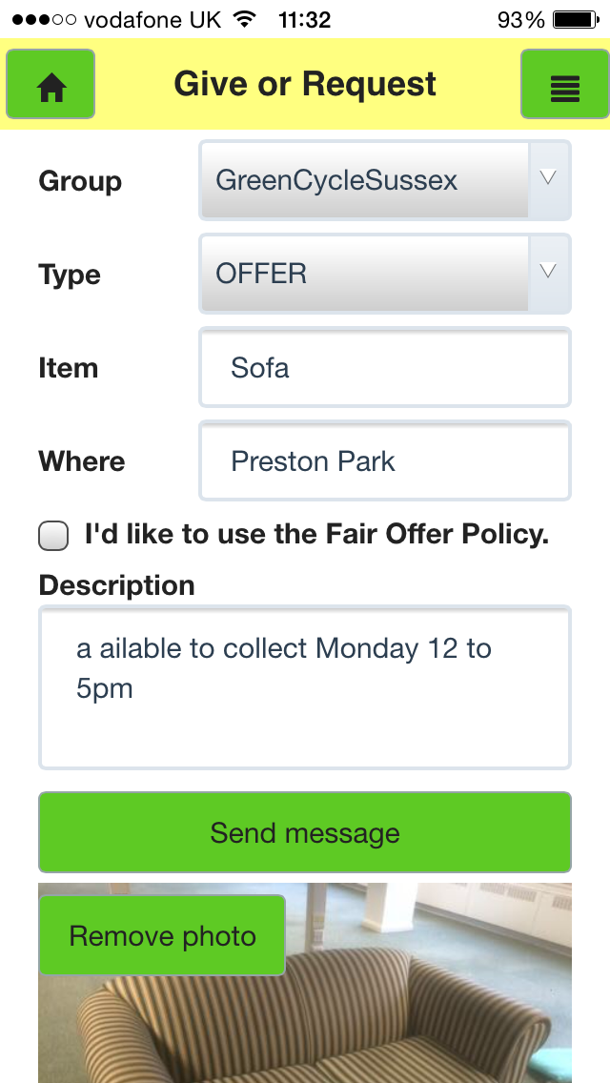
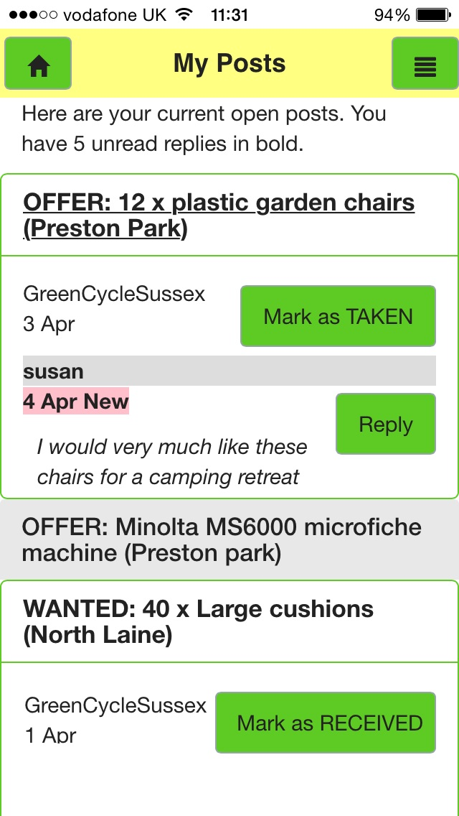

Download Free from these UK app stores:

www.ilovefreegle.org/mobile
Freegle Mobile App
for phones & tablets
Stuff you don't need? Freegle it!
Freegle Mobile App
for phones & tablets
Stuff you don't need? Freegle it!
Download Free from these UK app stores:

www.ilovefreegle.org/mobile

